1. What does symmetric distribution mean?

* **symmetric distribution** is a distribution in which the left and right sides mirror each other.
* The most well-known symmetric distribution is the normal distribution, which has a distinct bell shape.
* If you were to draw a line down the center of the distribution, the left and right sides of the distribution would perfectly mirror each other:

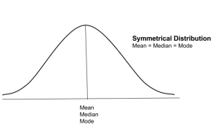

* For symmetric distributions, the skewness is zero.

1. what is left-skewed distribution and right-skewed distribution?

* A **left-skewed distribution** has a long-left tail. Left-skewed distributions are also called negatively-skewed distributions. That’s because there is a long tail in the negative direction on the number line. The mean is also to the left of the peak.
* A **right-skewed distribution** has a long right tail. Right-skewed distributions are also called positive-skew distributions. That’s because there is a long tail in the positive direction on the number line. The mean is also to the right of the peak.

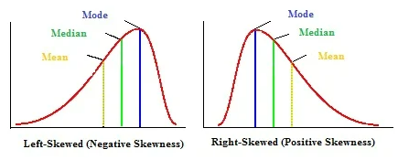

1. where are long-tailed distributions used?

one kind of heavy-tailed distribution is the **long-tailed distribution**, which is used to model many 𝐢𝐧𝐭𝐞𝐫𝐧𝐞𝐭-𝐞𝐫𝐚 𝐩𝐡𝐞𝐧𝐨𝐦𝐞𝐧𝐚 such as the frequency distribution of book titles sold at Amazon.com or the 𝐟𝐫𝐞𝐪𝐮𝐞𝐧𝐜𝐲 𝐨𝐟 𝐢𝐧𝐭𝐞𝐫𝐧𝐞𝐭 search terms.

1. what is the central limit theorem?

The **central limit theorem** (CLT) states that the distribution of a sample variable approximates a normal distribution (“bell curve”) as the sample size becomes larger, assuming that all samples are identical in size, and regardless of the population's actual distribution shape.

1. what are observational or experimental data in statistics?

* **Observational** study is a study in which the researcher simply observes the subjects without interfering. They just observe the subjects and record data based on their observations.
* **Experimental** studies are ones where researchers introduce an intervention and study the effects. Experimental studies are usually randomized, meaning the subjects are grouped by chance. Randomized controlled trial: Eligible people are randomly assigned to one of two or more groups.